Grafana Slack Integration

This solution is not working well. Unable to narrow download issue. We can use alert manager for alerting instead of Grafana. Find the difference from the article below.

<https://alexandre-vazquez.com/grafana-alerting-vs-alert-manager/>

<https://grafana.com/blog/2020/02/25/step-by-step-guide-to-setting-up-prometheus-alertmanager-with-slack-pagerduty-and-gmail/>

1. Create a Channel in Slack Application

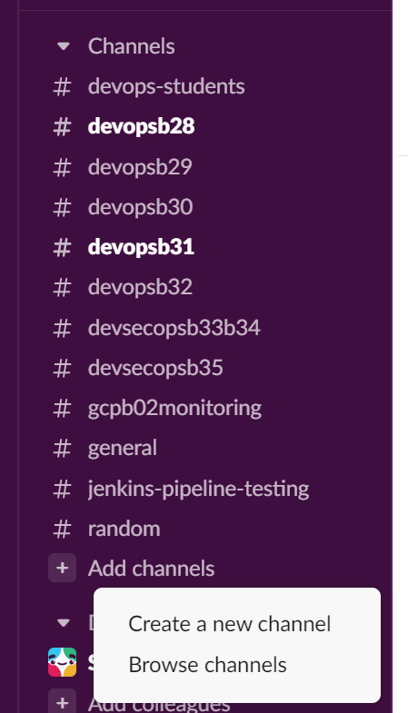

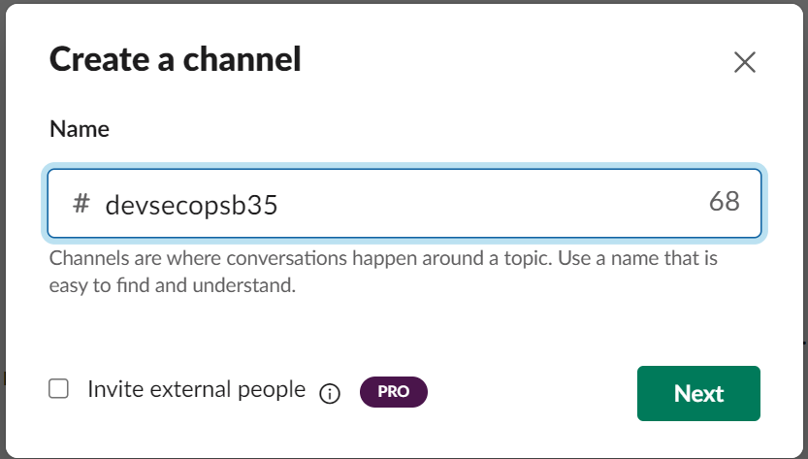

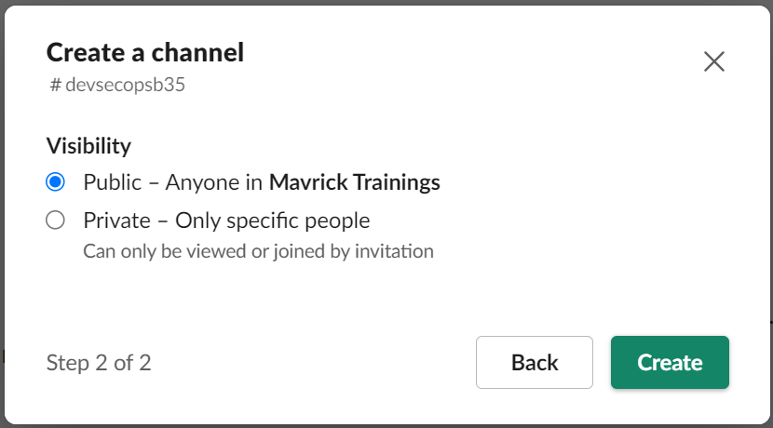

1. Go to the apps to add webhook.

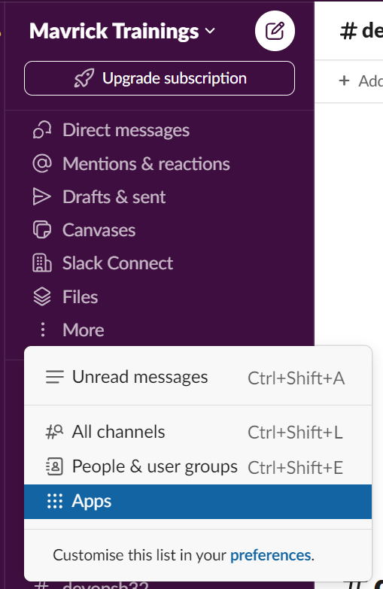

Search for Incoming Webhooks and CLick on Add.

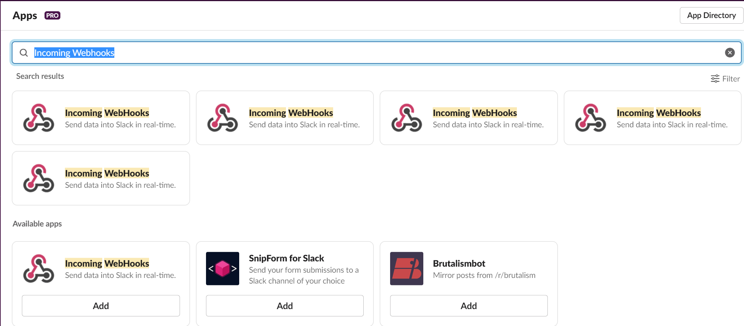

A new browser will be opened and click on”Add To Slack” as shown below.

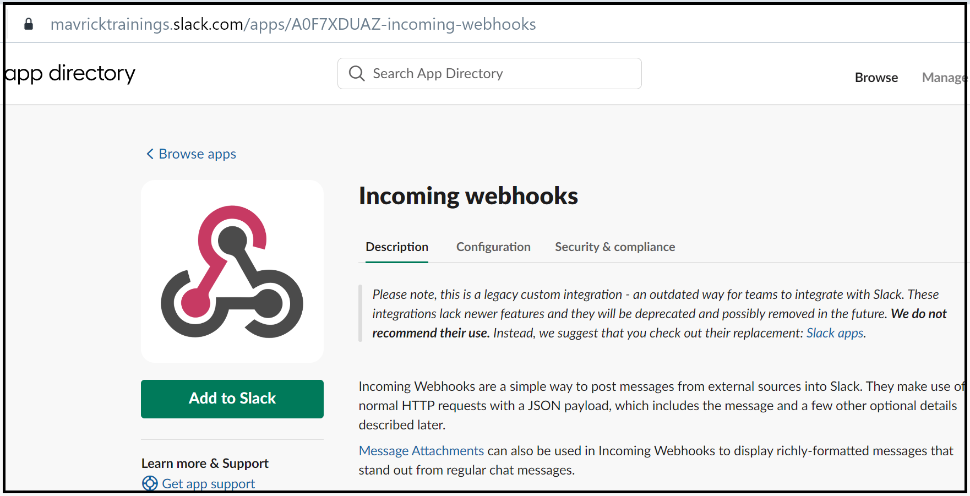

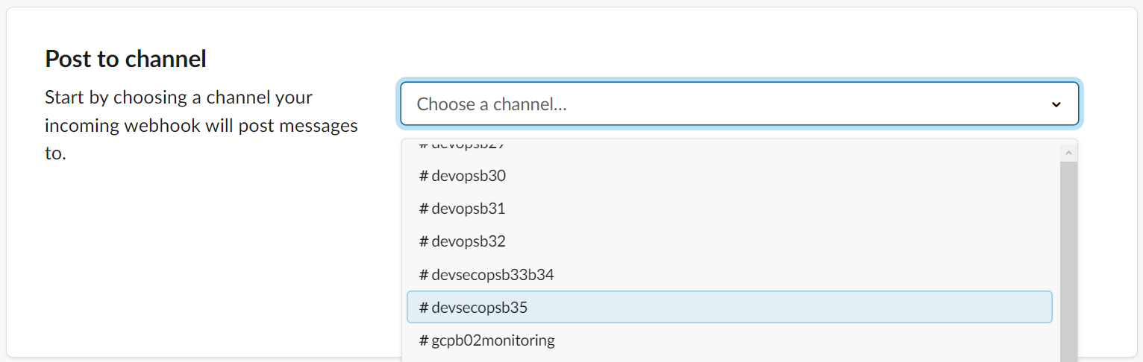

Click on 

Copy Webhook URL from Integration Settings and save it.

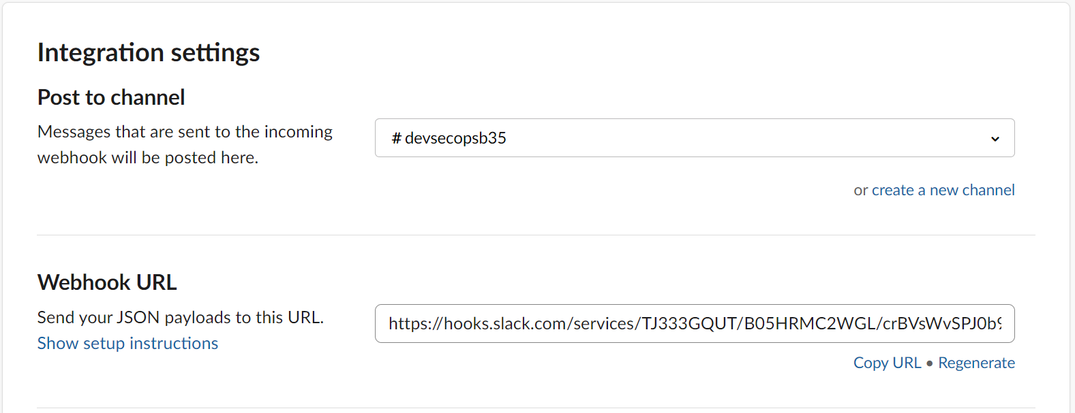

Go to “Contacts Points” under Alerting in Grafana Console.

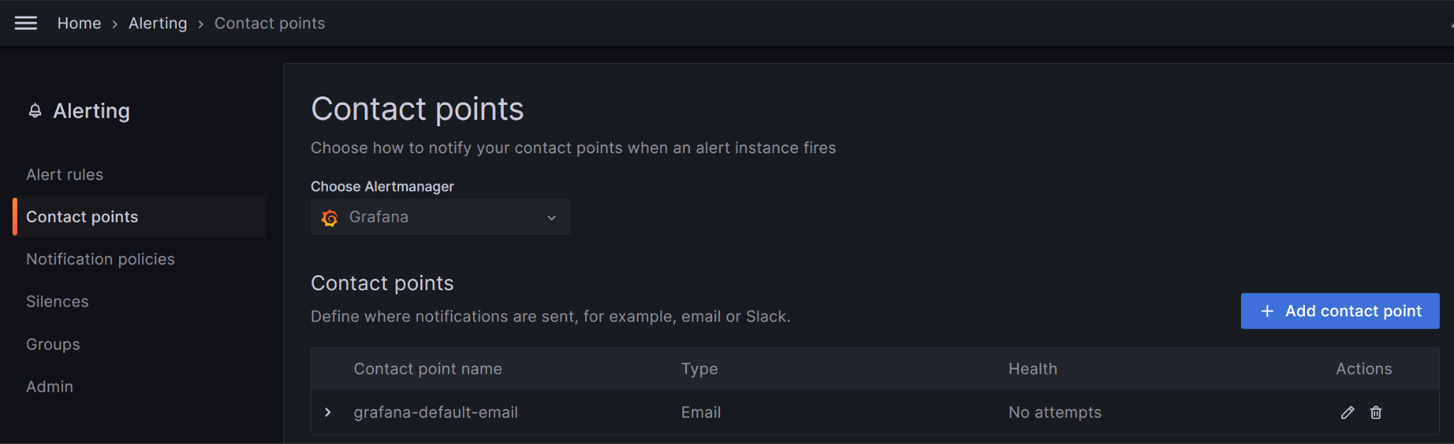

Create a new Contact Point for Slack and Provide the Webhook

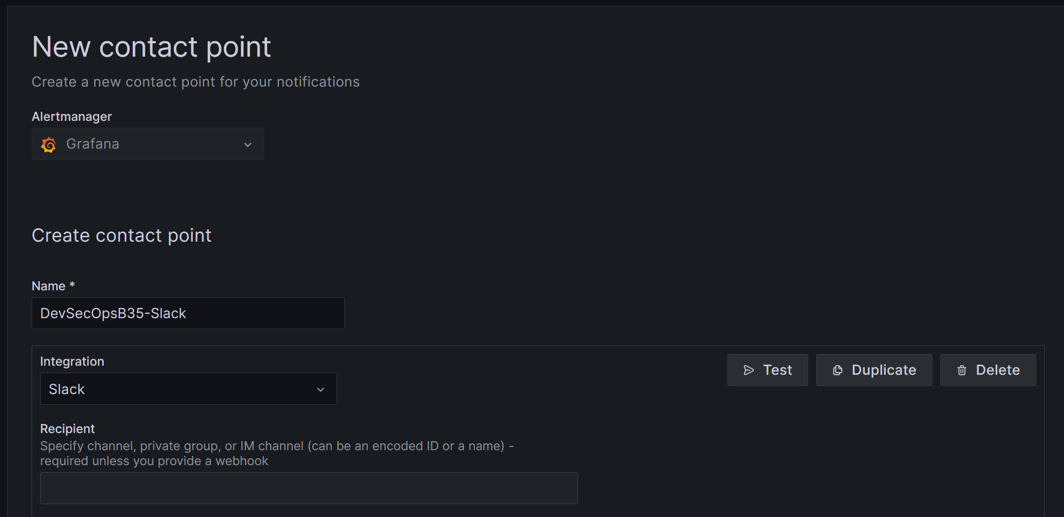

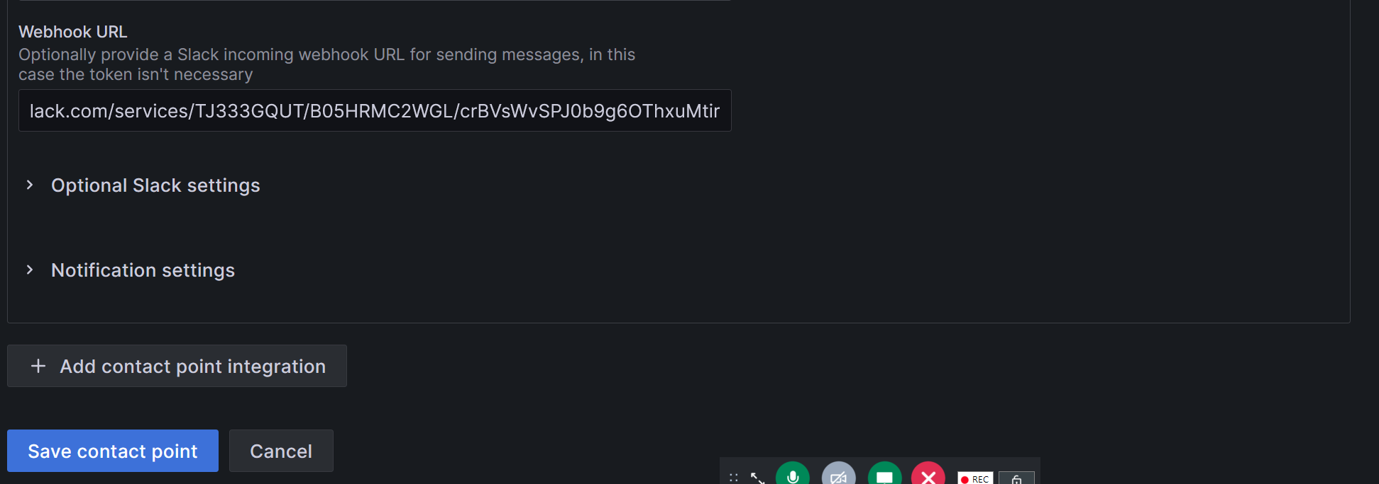

Click on Test to check Slack Connectivity.



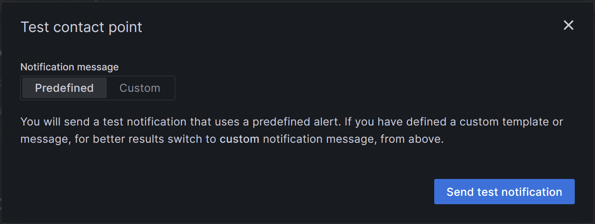



Check in Slack Console:

